Brainstorming for the keypad

We are currently looking at two routes for the keypad press for the Safecracking Robot. One thing I would like to mention is that we decided not to try to use a pressure sensor. This is because it may work for a safe that has had the same combination pressed into 100 times, and those buttons might have gotten worn out, but since this is a new safe, and the combination we will be hacking will be brand new, it doesn’t seem plausible that using a pressure sensor on the buttons would work.

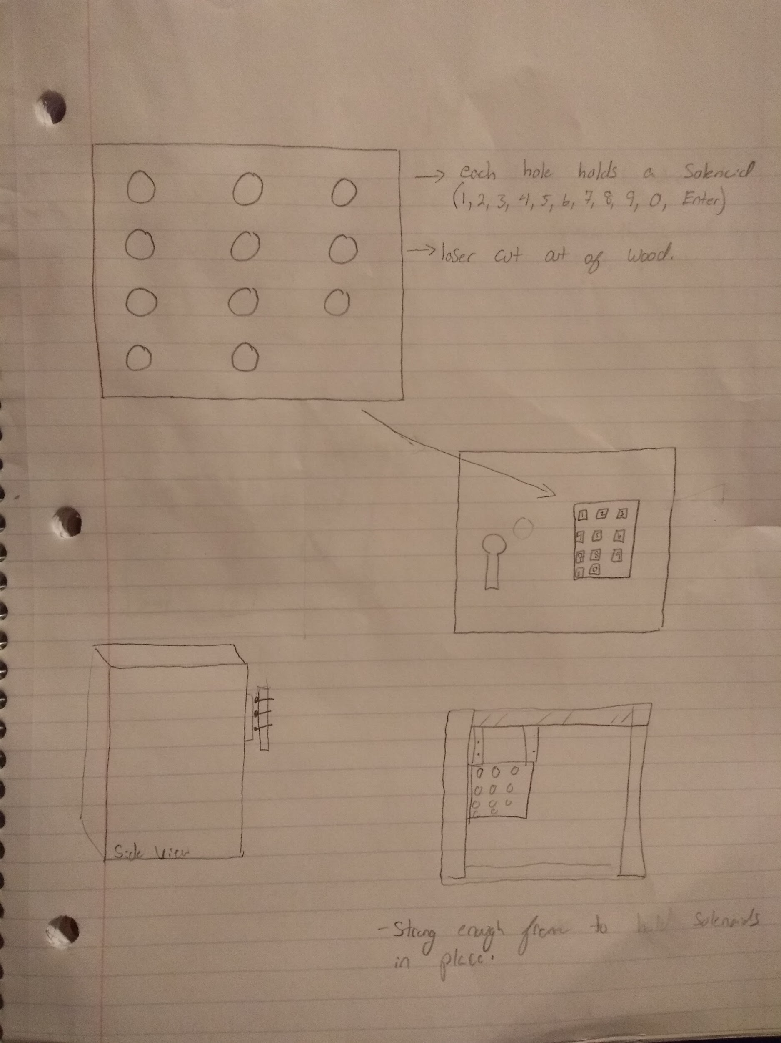

**1)** The first route is to use 11 different solenoids to press the keypad buttons. We would laser cut the holes on a wooden board and place the solenoids in each hole (in order to hold the solenoids steady) and mount that wooden board on our robot frame.

**Pros:** This would greatly decrease the amount of time needed to get into the safe, as we could program the solenoids to release to hit each button in the attempted combination faster than human fingers could do.

**Cons:** 11 solenoids (even the smaller 5V solenoids) add up fast, and would cost a lot of money. In addition, with 11 solenoids, we would need to find a large power source. It is also possible th solenoids don’t have enough force to hit the buttons.

**2)** Our second route is to use one solenoid (a more powerful 12V or 36V solenoid) and put it on a “track.” This track be laser cut, and will have one vertical Y track, and 4 horizontal X tracks. The Y track will be controlled by one motor, turning to the right to raise the solenoid, and turning left to lower the solenoid. The horizontal tracks will be controlled by two motors, one on the right, and one on the left. The solenoid would be attached to the motors by string, or wire or cables. 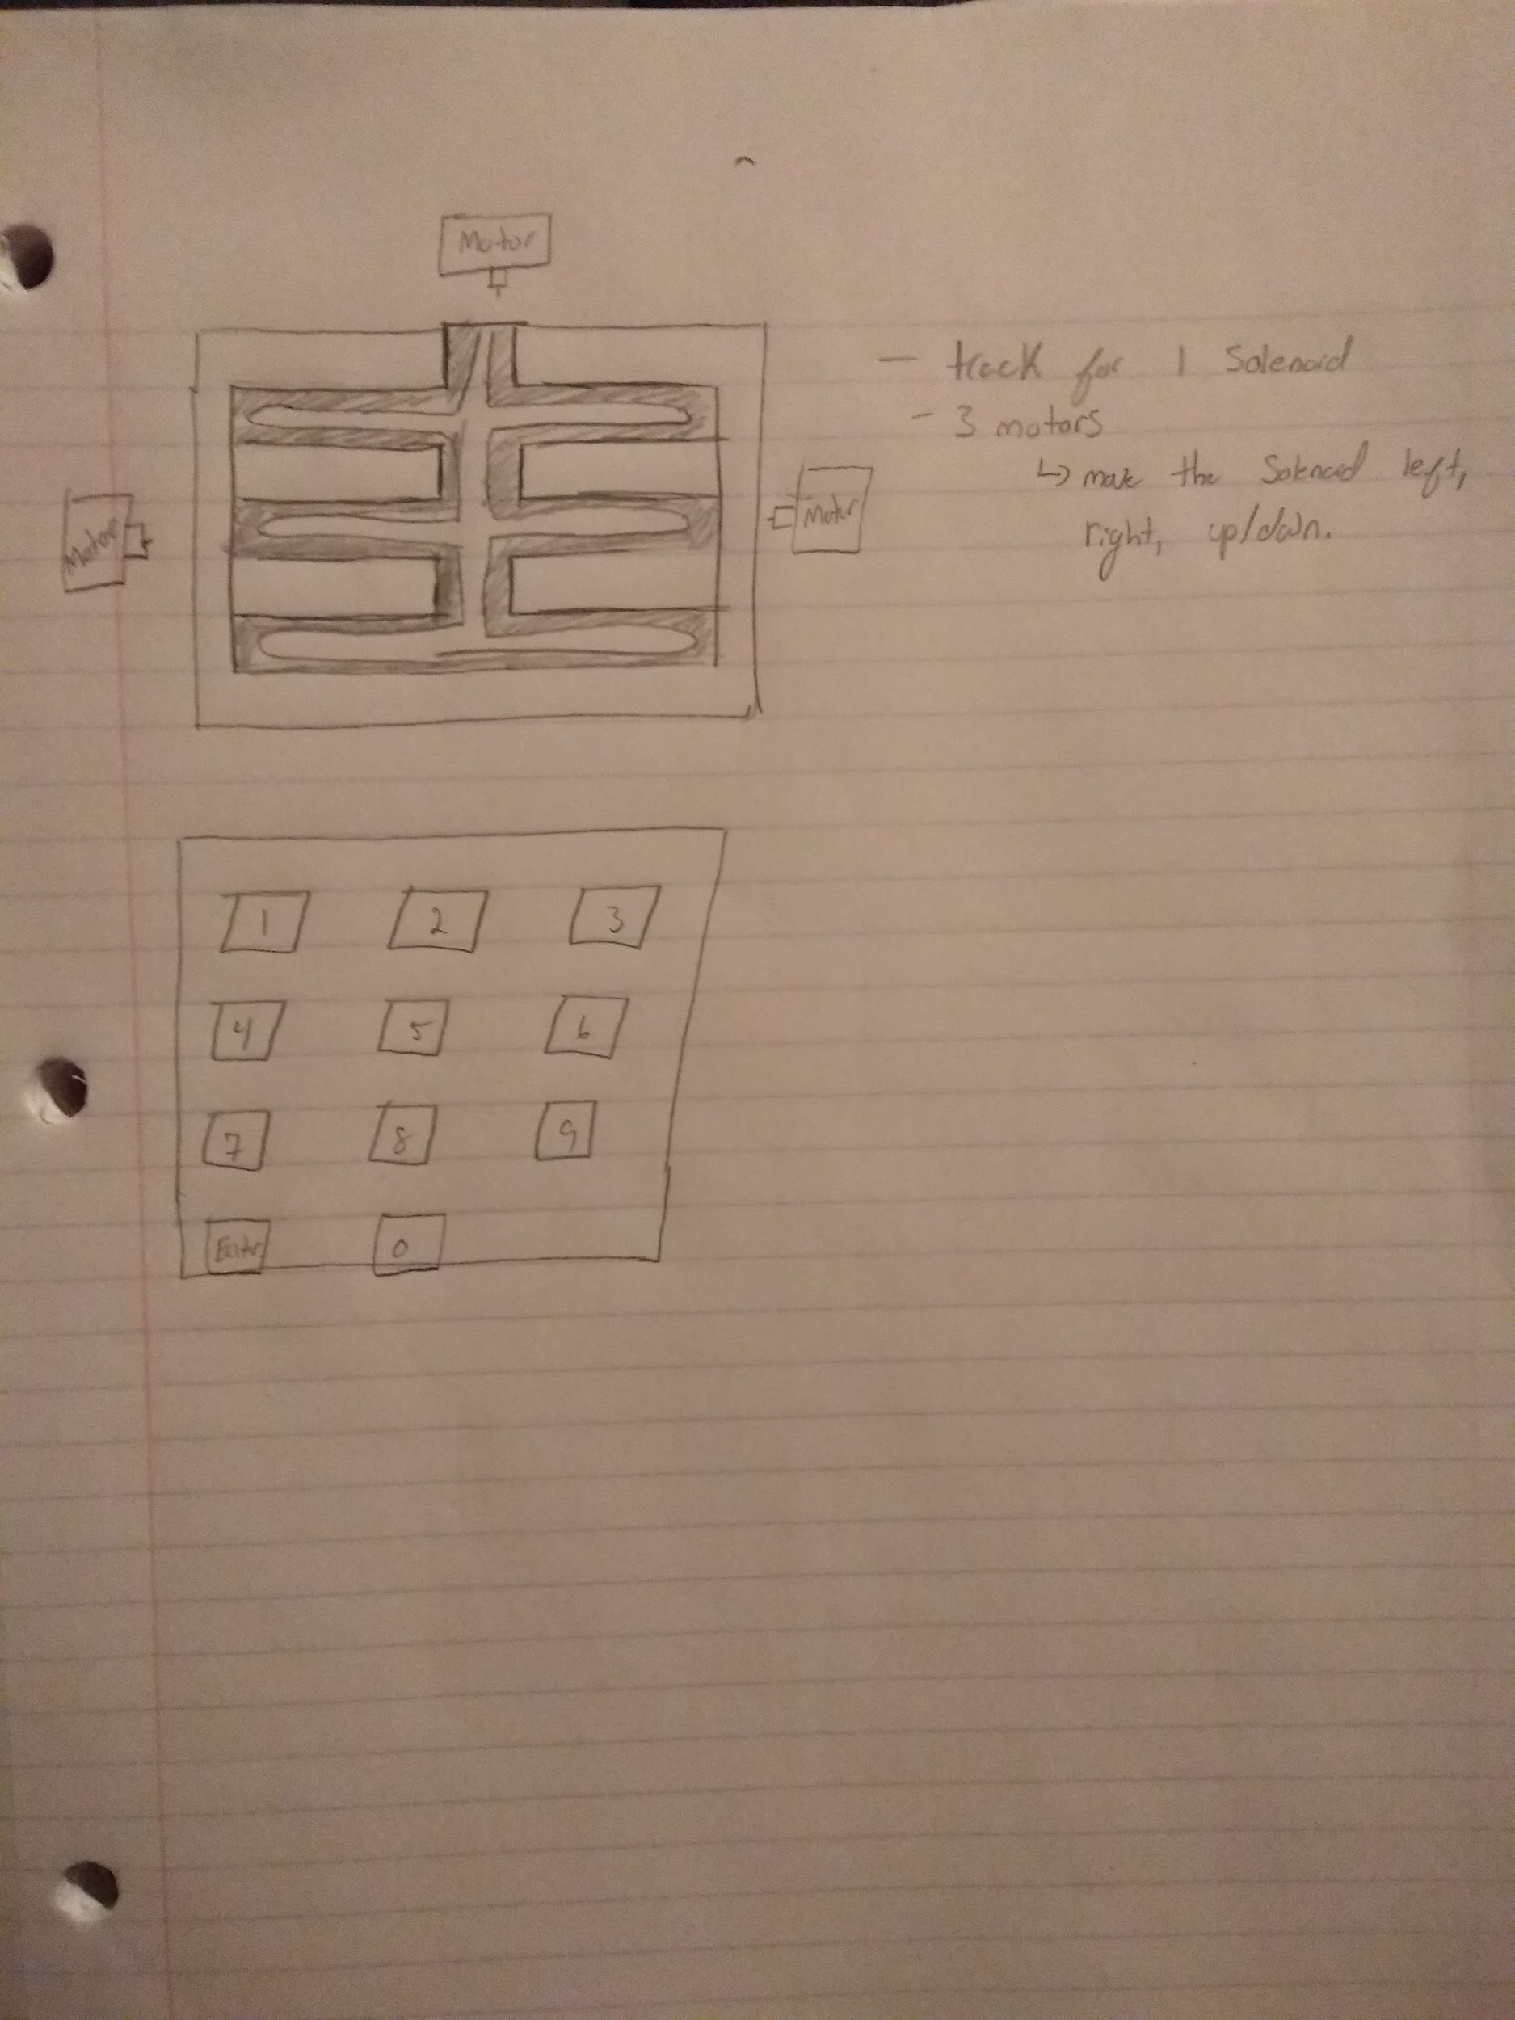

**Pros**: This would decrease the price of the robot, and by using a powerful solenoid, we have a better chance of pressing the buttons.

**Cons:** This would greatly slow down our robot, as one solenoid would have to move across the track to get to each button. We would also have to find a large power source, for one large solenoid, and 3 servo motors. The final con would be that this route would be a lot harder to code, because not only would we need the code to go through each combination, but we would need to associate each number with the motors/ solenoids position on the track.

**Parts List:**

1) Route 1

* Solenoids (11) ~$54.45 (SparkFun: https://www.sparkfun.com/products/11015)
* Wooden plank ~ $5
* Actobotics 12” (2)~$20 (SparkFun: https://www.sparkfun.com/products/12221)
* Actobotics 6’’ (2)~$12 (SparkFun: https://www.sparkfun.com/products/12164)
* Servo Motor
* Pully (optional, to open the door)

2) Route 2

* Solenoids (1) ~$18.95 (SparkFun: <https://www.sparkfun.com/products/10391>)
* Servo motors (4)~$34.8 (SparkFun: <https://www.sparkfun.com/products/9065>)
* Wooden plank ~ $5
* Actobotics 12” (2)~$20 (SparkFun: https://www.sparkfun.com/products/12221)
* Actobotics 6’’ (2)~$12 (SparkFun: <https://www.sparkfun.com/products/12164>)
* Pully (optional, to open the door)